UNIVERSITÀ DEGLI STUDI DI CATANIA
Agricultural, Food and Environmental Science
Xxxxx Cycle

Type_here_Manuscript_title

Type_here_Author_name

Advisor:
Type_here_Advisor_name

Co-advisor:
Type_here_Co_Advisor_name

Coordinator:
Type_here_Coordinator_name

Ph. D. attended during 20xx/20xx

Acknowledgements
(use “Normal” style)

Index
Insert here the index of the thesis (automatically)

1 Type_here_main_section_title (first level) 1
1.1 Type_here_sub_section_title (second level) 1
1.2 Type_here_sub_section_title (second level) 1
1.2.1 Type_here_sub_section_title (third_level) 1
2 Type_here_main_section_title (first level) 5
2.1 The GIS-based model 5

Table Index
Table 1.2 - Orange-producing farms in Italy (*) 4

Figure Index
Figure 1.1 - Type here the text of the caption (without bold character) (e.g., Geographical position of Sicily (Italy) 3

Research highlights
- Type_here_the_research_highlights_using_ “Paragrafo elenco”_style
- Global warming can impact food webs associated to insect pests
- I assessed the effects of increasing temperatures on four citrus pests and natural enemies
- In the laboratory, only sup-sucking pests increased their pest potential at high temperature
- The biocontrol services provided by parasitoids and predators decreased at high temperatures
- In the monitored fields, the population levels of the four pests were lower in cooler years
- Pest and natural enemy modelling supported the data obtained in the laboratory and in the field
- These results suggest a strong modification of the citrus food web by climate changes

Abstract
Type_here_the_abstract_using_ “Normal”_style

Keywords:

Riassunto
Type_here_the_abstract (in Italian) using_“Normal”_style
Parole chiave:

Type_here_main_section_title (first level)

Type_here_sub_section_title (second level)
Rapid growth of the population, along with accelerating industrialization and expanding urbanization, has dramatically changed our world. Signs of climate change rise concerns for the future of the planet. Emissions of carbon dioxide have increased by more than 80% since the early 70’s, mainly due to the increase in consumption of fossil fuels and changes in land use. The 2015 United Nations Climate Change Conference (officially known as Conference of the Parties COP 21) concluded the Paris Agreement, a global agreement on the reduction of climate change, in which global warming is set at the increase of less than 2 degrees Celsius (°C) compared to pre-industrial levels and the CO2 emissions reduction of 50% by year 2050. 85% of current energy consumption is based on fossil fuels, which is the most responsible source for greenhouse gas (GHG) emissions. According to the estimate of world energy requirement, demand would increase approximately 36% between 2008 and 2035.
To sustainably satisfy this demand, renewable energy technologies must be implemented to balance and reduce fossil energy use (Valenti et al. 2018).
[…]

Type_here_sub_section_title (second level)

Type_here_sub_section_title (third_level)
The sector of biogas production has been developed for more than 20 years with great success in Europe and mainly in Germany where about 8,000 plants were installed at the end of 2012. It is four times the number of plants present in the U.S. territory. By analysing the current and potential biogas production in U.S. territory, recent studies showed that there is a possibility of reaching 11,000 plants in relation to the actual sources of available biomasses and the methane potential production for three different biomass categories, such as landfills, wastewater, and livestock manure. Anaerobic digestion of livestock manure has been adopted by the State of California as an eligible project type for the generation of offsets under its statewide cap-and-trade program.
[…]

Type_here_sub_section_title (fourth_level)
Approximately 3.9 million metric tons of biomass residues are produced annually by Sicilian agriculture, representing a large untapped resource. The biomass includes wastes from agro-food processing (i.e., citrus pulp, olive pomace, and whey), livestock wastes (mainly from cattle), crop residues, some energy crops, and agricultural residues (waste fruit and vegetables). Among them, wastes from agro-food processing and livestock production account for more than 60% of the total biomass produced. Food wastes and animal manures are very good feedstocks for anaerobic digestion to produce biogas and liquid/solid fertilizers.
Anaerobic digestion of livestock manure has been adopted by the State of California as an eligible project type for the generation of offsets under its statewide cap-and-trade program
Citrus pulp has been utilised as the feedstock for production of animal feed simply burnt (due to its high calorific power: 4,545 kcal kg-1 dry matter), fertilizer, essential oils, pectin, ethanol, industrial enzymes, single cell proteins, pollutant absorbents and paper pulp supplement. However, these processes generate a large quantity of polluted wastewater, giving the fact that the pressing stage requires the addition of quicklime. Other factors that limited the reuse, exploitation, and valorisation of citrus pulp were the lack of official data related to the quantities, in terms of volumes, and the spatial localisation of the actual quantities of this by-product. Therefore, feasibility studies of citrus pulp valorisation were scarcely conducted by scientific communities.
Approximately 3.9 million metric tons of biomass residues are produced annually by Sicilian agriculture (Figure 1.1), representing a large untapped resource. The biomass includes wastes from agro-food processing (i.e., citrus pulp, olive pomace, and whey), livestock wastes (mainly from cattle), crop residues, some energy crops, and agricultural residues (waste fruit and vegetables) (Table 1.1).

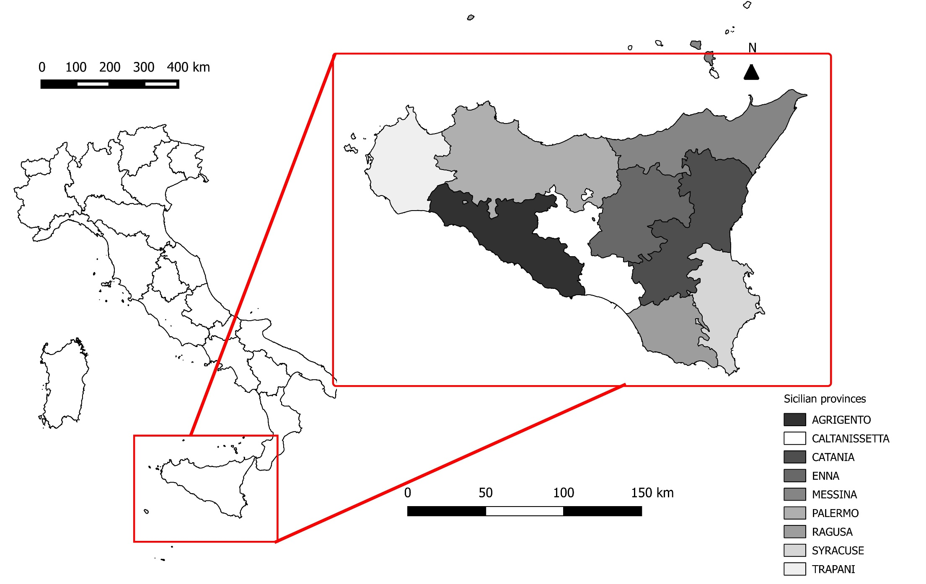

Figure 1.1 - Type here the text of the caption (without bold character) (e.g., Geographical position of Sicily (Italy)

Table 1.1 - Orange-producing farms in Italy (*)
 | Farms
 | Oranges |  |  | Total citrus
 | N. | % |  | N. | %
Liguria | 350 | 0.6 |  | 678 | 0.9
% | 51.6 |  |  | 100.0
Lazio | 1,035 | 1.8 |  | 1,205 | 1.5
% | 85.9 |  |  | 100.0
Campania | 2,921 | 5.1 |  | 4,679 | 5.9
% | 62.4 |  |  | 100.0
Puglia | 4,344 | 7.5 |  | 6,038 | 7.6
% | 71.9 |  |  | 100.0
Basilicata | 3,036 | 5.3 |  | 3,508 | 4.4
% | 86.5 |  |  | 100.0
Calabria | 14,148 | 24.5 |  | 20,974 | 26.4
% | 67.5 |  |  | 100.0
Sicilia | 27,020 | 46.8 |  | 36,981 | 46.5
% | 73.1 |  |  | 100.0
Sardegna | 4,467 | 7.7 |  | 4,946 | 6.2
% | 90.3 |  |  | 100.0
Other regions | 4,467 | 7.7 |  | 4,946 | 6.2
% | 90.3 |  |  | 100.0
Total | 57,724 | 100.0 |  | 79,589 | 100.0
% | 72.5 |  |  | 100.0
(*) Source: Istat.

Type_here_main_section_title (first level)

The GIS-based model
In this section, a model for the estimation of citrus pulp and olive pomace potential availability for biogas production at an established territorial scale (e.g., national, regional, or local) is proposed. The model is described in mathematical form. The choice of a rigorous mathematical form makes it possible to fulfil the repeatable nature of the scientific research without misinterpretation.
The model requires the use of a set of indicators that must be previously defined and quantified by means of suitable databases and field surveys (Pastell et al. 2009; Porto and Cascone 2013).
In order to estimate citrus pulp and olive pomace potential availability the following steps are required:
- Sub-setting of the study area (Catania province) in n zones (municipalities) suitable to compute the different levels of the index (i = 1 to n). Although the study area subdivision could be carried out by following different criteria (e.g., physiographic units, landscape units, geomorphologic units, geological units, iso-slope zones, agricultural units, and road-bounded areas), in this model the discretization methodology based on administrative boundaries makes it possible to obtain data from databases of agricultural production or other supports such as regional technical maps and ortho-photo images.
- Image processing for the classification of high-resolution satellite images could also be used for this purpose. For each i-th zone, computation of the indicators reported.

Use “Equation” style to write formulas
$$x=\frac{-b±\sqrt{b^{2}-4ac}}{2a}$$ | (1)
$$\cos{α}+\cos{β}=2\cos{\frac{1}{2}\left(α+β\right)}\cos{\frac{1}{2}\left(α-β\right)}$$ | (2)
$$\sin{α}±\sin{β}=2\sin{\frac{1}{2}\left(α±β\right)}\cos{\frac{1}{2}\left(α∓β\right)}$$ | (3)

References
Pastell, M., J. Tiusanen, M. Hakojärvi, and L. Hänninen. 2009. “A Wireless Accelerometer System with Wavelet Analysis for Assessing Lameness in Cattle.” Biosystems Engineering 104(4):545–51.
Porto, S. M. C. and G. Cascone. 2013. “A Building Characterization-Based Method for the Advancement of Knowledge on External Architectural Features of Traditional Rural Buildings.” Informes de La Construccion 65(532).
Valenti, F., Y. Zhong, M. Sun, S. M. C. Porto, A. Toscano, B. E. Dale, F. Sibilla, and W. Liao. 2018. “Anaerobic Co-Digestion of Multiple Agricultural Residues to Enhance Biogas Production in Southern Italy.” Waste Management 78.

